Dear Parents, 11/23/15

I want to take a moment to wish you a warm, safe, and happy holiday this week! With every passing day, we near the halfway mark of your child’s kindergarten year. It is passing very quickly!!!
As a hard working mom of 4, I understand the temptation to put school away for the next 5 days but let me encourage you to avoid that temptation. Your child’s momentum is high. Let’s keep it there! I’m not talking about extremes! Certainly relax and spend some family time with those who mean the most to you. There are ways to have your cake and eat it too!

-While you travel, pop in a book on CD. Let your child read along. I bet you’ll be amazed how far they’ve grown in such a short time! Be sure to ask questions about the book!

-While family is together, capitalize on the opportunity of your own “Mystery Reader”! Aunts, uncles, grandparents, and godparents LOVE the chance to snuggle with your little one and activate their imagination. These are the memories that make a holiday. :)

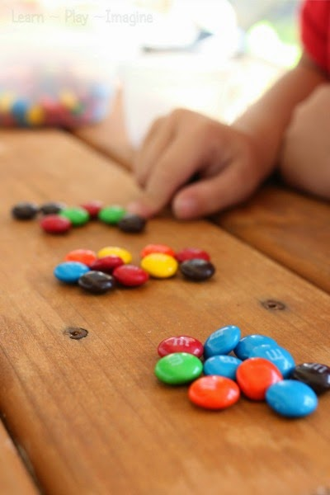
-As you travel, ask your child to read the speed limit signs (correctly). If they pronounce 45 as “four, five”, gently correct them.

-Ask your child to tell you how many “tens” and “ones” are in a number (on a sign, in a recipe, in a newspaper or magazine).

-Give your child M & Ms, skittles, chocolate chips, cheerios or any other treat that they may eat after they have counted and “built” a number in groups of tens and ones.

-Give your child creative ways to practice writing sight words!
-Food coloring and cool whip, smeared on a table gives a great space to use fingers to write words.
-Homemade playdough is fun! (recipe on my class website!) After your make it, use toothpicks, fingers, butter knife, golf tees, etc. to “write” words.

The sky's the limit! The point is, breaks are a wonderful opportunity for you to show your child that what they’re learning in school is applicable in the real world, valuable, and a priority for you.
Thank you for all that you do at home to support your child’s learning. I sincerely appreciate the time you dedicate to reading and sight words, even when you’re exhausted from a long work day and have an early morning coming. You make the critical difference!

Your partner in education,
Julie Stanley

